Draw one squad at a time, you need to provide vertex buffer, index buffer, and transform matrix

We can combine all the vertex buffers into one single vertex buffer, and all the index buffers into one single buffer, and draw the whole scene in one go.

We can’t use uniform for color.

Batch rendering for texture: we can use the 32 texture slots, for each slot, give it a texture map. And for each object, give it an id to point to that texture. The object can select that texture map in the fragment shader.

Or, we can combine those texture maps into one big texture map.

For each vertex, it contains 3 float for position, 4 float for color, and 2 float for texture coordinate.

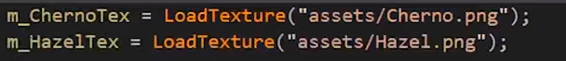

Now, add the texture id on the last column.

Add layout.



In the vertex shader

Finally, in the fragment shader.

If you have more than 32 texture (for example, 100 texture) that want to render at the same time, you still can use this strategy, but instead, each draw call, you can render a batch of 32 texture, and you need to separate the 100 texture into 4 batch.